Niessen Consultants
14 Forbes Lane
Andover, Massachusetts 01810
Telephone and Fax: (978) 470-4622
E-mail: Niessen@att.net

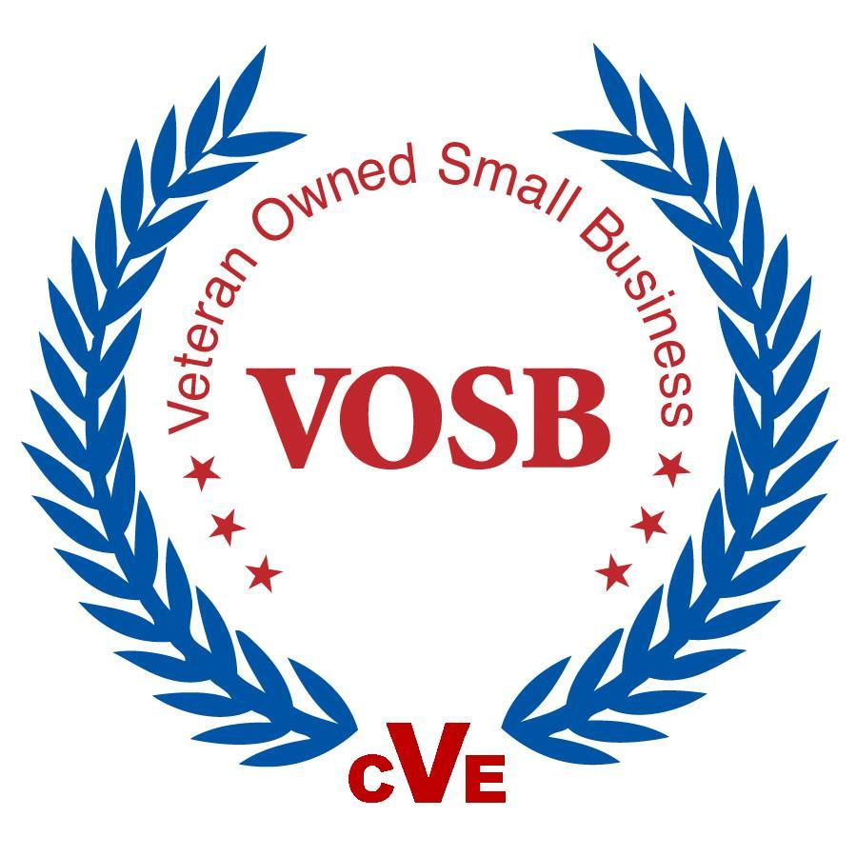


General Services Administration Federal Supply Service Authorized Federal Supply Schedule Price List

On-line access to contract ordering information, terms and conditions, up-to-date pricing, and the option to create an electronic delivery order are available through GSA Advantage!TM, a menu-driven database system. The Internet address for GSA Advantage!TM is: http://www.GSAAdvantage.gov.

Professional Engineering Services
SINFSC Group: 899 FSC Class: F999
Special Item No. 899-1 Environmental Planning Services and Documentation
Special Item No. 899-3 Environmental Occupational Training Services

Contract Number: GS-10F-043AA
Contract Period: November 15, 2012 – November 14, 2017
For more information on ordering from Federal Supply Services Schedules click on the FSS Schedules button at http//:www.gsa.gov/schedules-ordering
Contractor: Walter R. Niessen, DBA NIESSEN CONSULTANTS
14 Forbes Lane
Andover, MA 01810- 4106

Business Size: Small, Veteran Owned Business

Telephone: (978) 470-4622
FAX Number: (978) 470-4622
E-mail: niessen@att.net
Contract Administration: Walter R. Niessen, President

Table of Contents

CUSTOMER INFORMATION

1a. TABLE OF AWARDED SPECIAL ITEM NUMBERS…………………………………………………..….….. 3
1b. LOWEST PRICED MODEL NUMBER AND LOWEST UNIT PRICE………………….............................….…3
1c. HOURLY RATES, COMMERCIAL JOB TITLES, EXPERIENCE, FUNCTIONAL RESPONSIBILITY AND EDUCATION…………………………………………………………………………………..……………….… 3
2. MAXIMUM ORDER…………………………………………………………………………….............................3
3. MINIMUM ORDER………………………………………………………………………………………………..3
4. GEOGRAPHIC COVERAGE ……………………………………………………………………………………..3
5. POINT(S) OF PRODUCTION (CITY, COUNTY, STATE OR FOREIGN COUNTRY) …...................................3
6. DISCOUNT FROM LIST PRICES OR STATEMENT OF NET PRICE………………………..............................3
7. QUANTITY DISCOUNTS……………………………………………………………………..………………….3
8. PROMPT PAYMENT TERMS…………………………………………………………………..............................3
9a. GOVERNMENT PURCHASE CARDS (UP TO MICRO-PURCHASE THRESHOLD………..............................3
9b. GOVERNMENT PURCHASE CARDS (ABOVE MICRO-PURCHASE THRESHOLD………………………..4
10. FOREIGN ITEMS ………………………………………………………………….…………..………………….4
11a. TIME OF DELIVERY …………………………………………………………………………………………….4
11 b. EXPEDITED DELIVERY………………………………………………………….…………..………………….4
11 c. OVERNIGHT AND 2-DAY DELIVERY………………………………………….…………………………..…4
11 d.URGENT REQUIREMENTS……………………………………………………….………………………..……4
12. F.O.B POINTS(S) ………………………… ………………………………………………………………..…….4
13a. ORDERING ADDRESS…………………………………………………………………………………………..4
13b. ORDERING PROCEDURES………………………………………………………………………………….….4.
14. PAYMENT ADDRESS…………………………………………………………………………………………...4
15. WARRANTY PROVISION………………………………………………………………………………………4
16. EXPORT PACKING CHARGES…………………………………………………………………………………4
17. TERMS AND CONDITIONS OF GOVERNMENT PURCHASE CARD ACCEPTANCE……………….….…5
18. TERMS AND CONDITIONS OF RENTAL, MAINTENANCE, AND REPAIR…………………………….….5
19. TERMS AND CONDITIONS OF INSTALLATION (IF APPLICABLE) ………………………………..……...5
20. TERMS AND CONDITIONS OF REPAIR PARTS: INDICATING DATE OF PARTS PRICE LISTS AND
ANY DISCOUNTS FROM LIST PRICES……………………………………..…………………………………5
20a. TERMS AND CONDITIONS FOR ANY OTHER SERVICES…………………………………………..……....5
21. LIST OF SERVICE AND DISTRIBUTION POINTS……………………………………………………….…....5
22. LIST OF PARTICIPATING DEALERS ……………………………………………………….………………....5
23. PREVENTIVE MAINTENANCE……………………………………………….………………………………...5
24a. SPECIAL ATTRIBUTES SUCH AS ENVIRONMENTAL ATTRIBUTES, ( e.g.,
RECYCLED CONTENT, ENERGY EFFICIENCY, AND/OR REDUCED POLLUTANTS……………………5
24b. SECTION 508…………………………………………………………………………………….………………...5
25. DATA UNIVERSAL NUMBERING SYSTEM (DUNS) NUMBER………………….………………………….5
26. NOTIFICATION REGARDING REGISTRATION IN CENTRAL CONTRACTOR REGISTRATION (CCR) DATABASE………………………………………………………………………………………..……………...5
27. AUTHORIZED FEDERAL SUPPLY PRICE LIST……………………………………………..………………..5
28. SERVICE CONTRACT ACT……………………………………………………………………………..………5
29. LABOR CATEGORY DESCRIPTION FOR “PRINCIPAL”……………………………………………………..5

PROFESSIONAL ENGINEERING SERVICES INFORMATION

- CONTRACT OVERVIEW……………………………………………………………………..………………….6
- CONTRACT USE………………………………………………………………………...………………………..6
- CONTRACT SCOPE……………………………………………………………………………………………….6

RESUME OF WALTER R. NIESSEN P.E., B.C.E.E. ………………………………………. 8

CUSTOMER INFORMATION:

1a. Table of Awarded Special Item Number(s)

Special Item Numbers (SINs) | Page
SIN 899-1 Environmental Planning Services and Documentation | 5
SIN 899-3 Environmental Occupational Training Services | 5

DISCIPLINES: Chemical Engineering

The above SIN incorporates SIN 899-1RC and SIN 899-3RC to include Recover Purchasing in accordance with Section 833 of the National Defense Authorization Act for Fiscal Year 2007 for disaster relief. The pricing for 899-1RC,3RC is the same as for SIN 899-1,3.

1b. Lowest priced model number and lowest unit price
Not Applicable

1c. Hourly Rates, Commercial Job Title Descriptions, Experience, Functional Responsibility and Education

See Labor Category Descriptions, page 10.

2. Maximum Order:

The maximum order threshold value for task order under this contract is $1,000,000.

3. Minimum Order:
The minimum order that may be placed under this contract is $100.00

4. Geographic Coverage (delivery Area): Domestic and Overseas
The geographic scope of this contract is within the 48 contiguous states, Washington, D.C., Alaska, Hawaii, Puerto Rico and, on a worldwide basis, in any foreign country in which trade is not prohibited by the United States Government.

5. Point(s) of production (city, county, and state or foreign country):

Not Applicable

6. Discount from list prices or statement of net price:

Government net prices (discounts already deducted). See Attachment.

7. Quantity discounts:

Niessen Consultants offers GSA additional quantity discount of 3% off task orders exceeding $150K, 5% off task orders exceeding $500K and 6% off tasks orders exceeding $1M.

8. Prompt payment terms: Net 30 days

9a. Government purchase cards (up to the micro-purchase threshold)

Niessen Consultants will accept Government purchase cards equal to or less than the micropurchase threshold for oral or written delivery orders.

9b. Government purchase cards (above micropurchase threshold)
Niessen Consultants will accept Government purchase cards over $2,500. In addition, if requested, bank account information for wire transfer payment will be shown on the invoice. If wire transfers are employed, however, a fee for this payment mode will be appended to the invoice.

10. Foreign items (list items by country of origin):

Not Applicable

11a. Time of Delivery:

Specified on the Task Order

11b. Expedited Delivery

Not Applicable

11c. Overnight and 2-day delivery

Not Applicable

11d. Urgent Requirements.

When the Federal Supply Schedule contract delivery period does not meet the bona fide urgent delivery requirements of an ordering agency, agencies are encouraged, if time permits, to contact Niessen Consultants for the purpose of obtaining accelerated delivery. Niessen Consultants shall reply to the inquiry within 3 workdays after receipt; confirmed in writing. If Niessen Consultants is able to offer an accelerated delivery time acceptable to the ordering agency, any order(s) placed pursuant to the agreed upon accelerated delivery time frame shall be delivered within this shorter delivery time and in accordance with all other terms and conditions of the contract.

12. F.O.B Points(s):

Destination

13a. Ordering Address(es):

Niessen Consultants
14 Forbes Lane
Andover, MA 01810-4106
Phone and Fax: (978) 470-4622
Email: Niessen@att.net

13b. Ordering procedures
For supplies and services, the ordering procedures, information on Blanket Purchase Agreements (BPA’s) and a sample BPA can be found at the GSA/FSS Schedule homepage (fss.gsa.gov/schedules).

14. Payment address
Niessen Consultants
14 Forbes Lane
Andover, MA 01810-4106
Phone and Fax: (978) 470-4622

15. Warranty provision
Niessen Consultants’ standard commercial warranty.

16. Export Packing Charges
Not Applicable
17. Terms and conditions of Government purchase card acceptance
Contact Niessen Consultants

18. Terms and conditions of rental, maintenance, and repair
Not Applicable

19. Terms and conditions of installation
Not Applicable

20. Terms and conditions of repair parts indicating date of parts price lists and any discounts from list prices
Not Applicable

20a. Terms and conditions for any other services
Not Applicable

21. List of service and distribution points
Not Applicable

22. List of participating dealers
Not Applicable

23. Preventive maintenance
Not Applicable

24a. Environmental attributes
Not Applicable

24b. Section 508
Niessen Consultants will fully comply with Section 508 standards as found in www.Section508.gov/.

25. Data Universal Numbering System (DUNS) number
016848306
26. Notification regarding registration in Central Contractor Registration (CCR) database
Niessen Consultants is registered in CCR.

27. Authorized Federal Supply Schedule Price List:

28. Service Contract Act:

The Service Contract Act (SCA) is applicable to this contract as it applies to the entire Environmental Schedule and all services provided. While no specific labor categories have been identified as being subject to SCA due to exemptions for professional employees (FAR 22.1101, 22.1102 and 29 CRF 541.300), this contract still maintains the provisions and protections for SCA eligible labor categories. If and / or when the contractor adds SCA labor categories / employees to the contract through the modification process, the contractor must inform the Contracting Officer and establish a SCA matrix identifying the GSA labor category titles, the occupational code, SCA labor category titles and the applicable WD number. Failure to do so may result in cancellation of the contract.

29. Labor Category Description for “Principal”
The category “Principal” relates to an individual with a Master’s Degree in Chemical Engineering and in excess of 45 years of professional experience in providing consulting services in environmental engineering with a focus on issues relating to waste management (domestic, industrial, commercial, medical, hazardous, radioactive etc.) and air pollution generation and control. They should have a Professional Engineer’s License and be Board Certified as an Environmental Engineer by the American Academy of Environmental Engineering in both Solid Waste and Air Pollution Control.

A “Principal” is a senior staff member and is not subject to the Service Contract Act (SCA).

PROFESSIONAL ENGINEERING SERVICES INFORMATION

1. Contract Overview
Niessen Consultants has been awarded a GSA Federal Supply Schedule contract for Professional Engineering Services (PES), Contract No. GS-10F-0336Y. Our initial contract period is from 4 June 2012 through 3 June 2012. The contract provides for task orders to be placed as Fixed Price or Time-and-Materials using the labor categories and ceiling rates defined for the contract.
2. Contract Use
This contract is available for use by all federal government agencies as a source for Professional Engineering Services for domestic and/or overseas use. Executive agencies, other Federal agencies, mixed-ownership Government corporations, and the District of Columbia; Government contractors authorized in writing by a Federal agency pursuant to 48 CFR 51.1; and other activities and organizations authorized by statute or regulation to use GSA as a source of supply may use this contract. Additionally, contractors are encouraged to accept orders received from activities within the Executive Branch of the Federal Government.
3. Contract Scope
The Special Item Numbers (SINs) available under this contract provide for Environmental Planning Services and Documentation (SIN 899-1) and Environmental Occupational Training Services (SIN 899-3). Task orders for outsourcing of engineering services may be placed for the above SINs, provided the work being outsourced is covered under the SIN definition.
A full description of the SIN definition and examples of the types of work covered by the SIN is provided below.
● 899-1 Environmental Planning Services and Documentation
Services under this SIN include, but are not limited to: Environmental Assessment (EA) and Environmental Impact Statement (EIS) preparation under the National Environmental Policy Act (NEPA); Environmental program and project management; Environmental regulation development; Economic, technical and/or risk analysis; other environmentally related studies and/or consultations; Compliance Services such as review, audit, and implementation/management of EMS and other compliance and contingency plans and performance measures; Permitting; Spill prevention/control and countermeasure plans; Pollution prevention surveys; and Community Right to-Know Act reporting. Advisory Services for ongoing advice and assistance with data and information in support of agency environmental programs involving areas such as Hazardous material spills; Environmental regulations and environmental policy/procedure updates; Waste Management Consulting Services to provide guidance in support of waste-related data collection, feasibility studies and risk analyses; Resource Conservation and Recovery Act/Comprehensive Environmental Response Compensation and Liability Act (RCRA/CERCLA) site investigations; Hazardous and/or non-hazardous exposure assessments; Waste characterization and source reduction studies; Review and recommendation of waste tracking or handling systems; Waste management plans and/or surveys; Waste minimization/pollution prevention initiatives; and Review of technologies and processes impacting waste management.
Example: The development and analysis of the use profile, operating conditions, air emissions, energy recovery potential, air pollution control requirements and air permitting for an industrial waste incineration system including examination of performance and cost tradeoffs.

● 899-3 Environmental Occupational Training SerVICES
Services under this SIN include, but are not limited to aid agencies in training personnel in a variety of environmentally related subjects in order to meet Federal mandates and Executive Orders. Environmentally related training can be conducted on- or off-site using standard off-the-shelf, customized, or computer/web-based interactive courses. Examples of environmental training courses include: Environmental management planning and operations and maintenance (O&M) planning; Compliance with environmental laws/regulations; Comprehensive Environmental Response Compensation and Liability Act (CERCLA); Emergency response plans; Environmental audits, awareness, compliance, and management; Fire preparedness training; First responder; Hazardous materials and waste (HAZMAT) training to include compliance, operation, packaging, handling, generators, and incident response; Hazardous waste operations and emergency response (HAZWOPER) training inclusive of transportation, storage and disposal; ISO 14001 Environmental Management Systems (EMS); Lead training to include awareness, inspecting, assessing, rehabilitation, and renovation; Mold (abatement, assessment); National Environmental Policy Act (NEPA); Occupational Safety and Health Administration (OSHA); Pollution prevention; Public fire safety education; Resource Conservation and Recovery Act (RCRA); Sustainable environmental practices; and existing and emerging technology review and analysis strategies.

Example: Training of staff members in existing and new technology such as gasification of domestic, industrial and hazardous wastes.

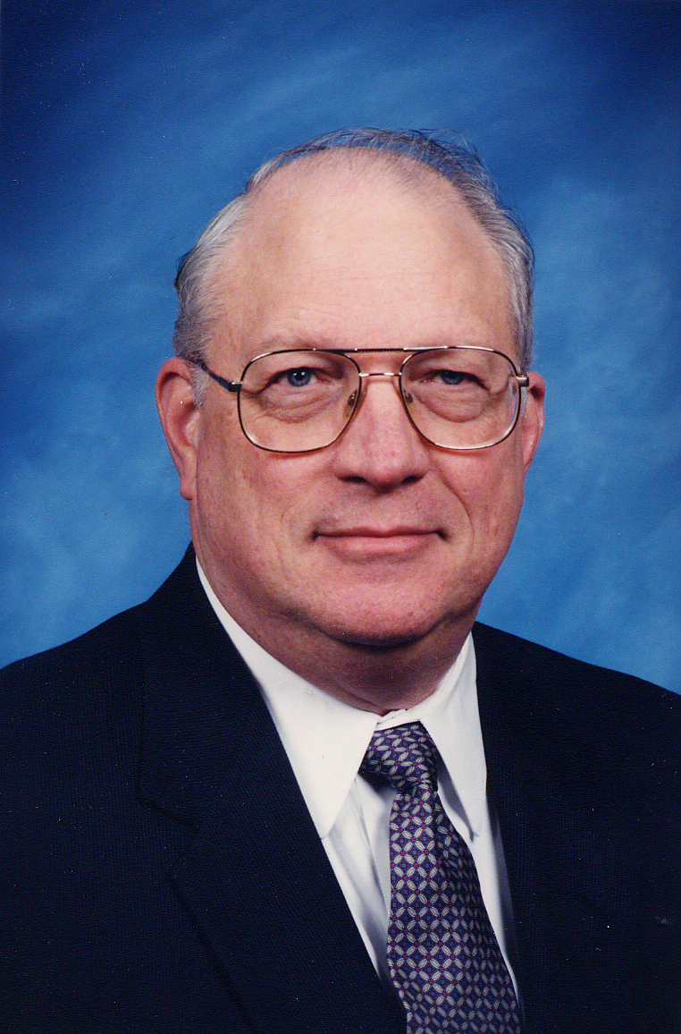
Walter R. Niessen, P.E., B.C.E.E
President, Niessen Consultants
Certified Veteran-Owned Small Business

Nationality United States
Year of Birth 1938
Profession Chemical Engineer
Specialization Waste management & associated air pollutant generation & control

KEY QUALIFICATIONS

Specialist in process analysis of waste management and associated air pollution systems with 50 years experience with municipal, industrial, medical, biosolids and hazardous wastes. The technical content of the work has included all aspects of project development: problem definition, analysis of combustion and air pollution, energy recovery alternatives, environmental assessments, and procurement steps (requests for bid, bid review, contract negotiations), designing, construction, start-up and acceptance testing and troubleshooting for operating systems. He brings specialist experience in preparing pre-feasibility studies, feasibility studies, conceptual studies, strategies of waste management for local and national governments and industries, waste management plans and presenting seminars on waste management and related technology.

EDUCATION AND PROFESSIONAL STATUS
MSc in Chemical Engineering, M.I.T. – Cambridge, Massachusetts, USA, 1961

BSc in Chemical Engineering, – Cambridge, Massachusetts, USA, 1960

Registered Professional Engineer in Massachusetts (1971) and New Hampshire (1978)
Board Certified Environmental Engineer by American Academy of Environmental Engineers in both Solid Waste and Air Pollution Control (1974)
EMPLOYMENT RECORD

1999 – present NIESSEN CONSULTANTS S.P., Andover, MA, U.S.A.
Owner and President

Responsible for projects of municipal solid waste incineration, biosolids incineration and associated air emission control: feasibility studies, conceptual design, implementation strategy, plans, and due-diligence

Experiences during the stage of designing or construction waste thermal treatment plants.

1976 - 1999 CAMP DRESSER & McKEE INC. , Cambridge, MA, U.S.A.
Senior Vice President, Manager, Waste Management Group

Responsible for projects of municipal, industrial, hazardous, medical and biosolids waste management: pre-feasibility studies, feasibility studies, conceptual studies, strategy of waste management for local and national governments and industrial firms, technical advisory during the design and construction of installation of waste treatment; waste management plans; preparing and delivering seminars on waste management.

1973-1976 ROY. F. WESTON INC. West Chester, MA, U.S. A.
Manager, Air Quality and Waste Management Group
Responsible for projects of municipal, industrial, hazardous, medical and biosolids waste management: pre-feasibility studies, feasibility studies, conceptual studies, strategy of waste management for local and national governments and industrial firms; waste management plans; preparing and delivering seminars on waste management.

1972-1973 BOLT, BERANEK & NEWMAN INC. Cambridge, MA, U.S.A.
Manager, Environmental Systems Group

Responsible for business development and technical projects including environmental impact statements, incinerator combustion and air pollution control.

1964 - 1972 ARTHUR D. LITTLE INC. Cambridge, MA, U.S.A.
Staff, Chemical Engineering Group

Responsible for studies in energy and air pollution; project manager of major USEPA study on air pollution aspects of municipal waste incineration. Staff engineer in detailed design of advanced 450 ton/day municipal incineration system.

1961 - 1964 UNITED STATES AIR FORCE Edwards Air Force Base, CA, U.S.A.
Project Officer for combustion and ignition of solid propellant rockets

Responsible for development and monitoring of contract research and conducting in-house developmental research programs relating to solid rocket motor and propellant combustion and ignition.

PROFESSIONAL EXPERIENCE

Summary Mr. Niessen is a senior technical consultant engaged in assignments involving process analysis and feasibility studies, design, impact assessment, planning and startup, expert witness litigation testimony, and operations assistance. The subject matter varies widely but focuses on the management of biosolids and hazardous/non-hazardous solid, liquid and gaseous wastes and the associated air pollution problems (particulate, air toxics, NO_{x}, acid gases, odors, etc.) Mr. Niessen’s role includes leadership, training and/or consulting on projects drawing on over 45 years of professional experience in applied combustion technology, air pollution control and solid waste management. He has written over 95 technical papers on these subjects, contributed chapters to several environmental engineering books and authored a definitive text on combustion and incineration technology “Combustion and Incineration Processes, Applications in Environmental Engineering” now in its 4th edition.

Professional Experience

Solid Waste

Mr. Niessen has been involved in numerous municipal solid waste management planning studies and designs throughout his professional career. This work has been provided for a range of communities, from small jurisdictions such as Durham, NH; Logansport, IN; and Kokomo, IN through larger cities and regions such as the City of Chicago, the Connecticut Resources Recovery Authority (CRRA), the seven-county region around Baltimore, MD; Berkley Co., SC; New York City, NY; Durban, South Africa; Hillsborough, Pasco and Lee Counties in FL; Oakland County, MI; the Hackensack Meadowlands, NJ; Middlesex County, NJ; Erie-Niagara Counties and Oneida County, NY; and includes international assignments in Hong Kong, Barbados, Lebanon, Jamaica, Thailand, New Zealand, Mainland China and Taiwan. In these assignments, he analyzed a broad range of strategies using recycling, landfill, waste minimization, and resource recovery to develop balanced and workable solutions to the severe environmental, economic and technical challenges of waste management.

His project implementation efforts have included designs for Durham, NH and Windham, CT (both three, 36-tpd modular combustion units (MCUs); Hillsborough County, FL (1,200 tpd); Pasco Co., FL; Kent County, MI (650 tpd); Bristol, CT (650 tpd); New York Port Authority, NJ (2,500 tpd); Oakland County, MI (1,500 tpd); Lancaster County, PA (1,500 tpd); Onondaga County, NY (1,200 tpd); and North American Incinerator Inc. (450-tpd unit). He has also been involved in feasibility studies involving MCU systems (Green Bay and Sheboygan, WI; Kokomo, IN); larger, water wall combustion and gasification units (Middlesex County, NJ; Jacksonville, FL; Oakland County, MI; Chicago, IL; San Jose, CA;); sludge incineration in conventional and special design systems (Passaic Valley Sewerage Commission; Manchester, NH; Prince William County, VA; Detroit; New York City; Milwaukee); carbon regeneration (Niagara Falls, NY; Fitchburg, MA); hazardous waste incinerators for liquid, solid, and gaseous RCRA and CERCLA wastes; and specialized industrial waste systems (OII Landfill, Pueblo Army Post (chemical agents), Rocky Mountain Arsenal (pesticides), the Beijing Industrial Hazardous Waste Complex, General Motors, Polaroid, Ortho Pharmaceutical, GTE, Flambeau Paper, Genco hazardous waste incineration facility in Bangkok, and the American Gas

He has carried out many detailed technical, environmental and economic evaluations of emerging new technologies for solid waste and/or sludge gasification, incineration and air pollution control systems for private investors, investor groups and potential owners/users of systems. The CRRA, with their interest in solid waste gasification technology was one such client. The technologies Mr. Niessen has evaluated in depth include: include:
Technology Client Technology Client
Coal Gasification Texaco Ecologenics (I-SW) Gulf & Western
Hydrosonics Scrubber Detroit Battelle Fluid Bed (I-SW) NREL
Landgard (G/I-SW) USEPA EcoRock (I-SW) USEPA
Woetschke (G/I-SW) USEPA Kubota (G/I-Sludge) Passaic Valley
American Thermogen Mobile Incinerator of
"Melt-Zit" (I-SW) USEPA New England (I-SW) Investor Group
Purox (G/I-SW) USEPA PryoMagnetics (I-SW) Ryder Systems
Shirco (I-Sludge) Investor Group Garrett Corp (G-SW) USEPA
CPU-400 (I-SW) USEPA Clean Air Radicator (I-SW) Midland Ross Corp.
ThermoSelect (G-SW) NREL, CRRA Pedco (I-SW) NREL
Torrax (G/I-SW) Carborundum Co SilvaGas (I-SW) USEPA
Koppleman Process (G/SW) Investor Group Wellman-Lord SO2 (A) Tampa Electric
ThermoChem (G-SW) NREL Takuma (G/I-Sludge) Datona Beach FL
Ionics SO2 Process (A) Tampa Electric Proler (I-SW) NREL
Lantz Converter (G-SW) USEPA Beijing DangDai (I-SW) Képpel Fels Ltd.
British Gas/Lurgi (G-SW) CRRA Energy Products of Idaho (I-SW)NREL
International Environmental InEnTe, Plasma Induced
Solutions (G-SW) Chicago Melter (G-SW) Chicago
Alter NRG Chicago Termiska AB (G-SW) NREL
Ebara TwinRec Cicago Nippon Steel (G-SW) Chicago

G=Gasification, I= Incineration, SW = Solid Waste, A=Air Pollution Control, Sludge= Biological Sludge

His work has included assessments of a number of unusual waste incineration challenges to include bio-hazardous waste (carcases contaminated with prions associated with bovine spongiform encephalopathy or “Mad Cow disease,” and test animal cage waste); toxic military wastes (nerve gas and mustard gas, contaminated soils); munitions (off-specification or out-of-date cartridges and shells); explosives (e.g. benzoyl peroxide); and radioactive wastes (low-level wastes, contaminated soils).

Mr. Niessen conducted a major study for the National Renewable Energy Laboratory (a laboratory of the U.S. Department of Energy) that provided a comprehensive overview of emerging municipal solid waste gasification and pyrolysis-based thermal processing technology.

Mr. Niessen worked extensively in the conversion of stoker- and suspension-burning coal-fired boilers to burn prepared refuse. This work included in-depth consideration of the mating of fluid bed combustion chambers to existing boilers. Most frequently, the boilers were part of an existing electrical utility generating plant or paper mill boiler plant such that the energy conversion infrastructure (boiler water treatment, electrical generation, feedwater heating, deaerators etc.) was in place at no cost.

Mr. Niessen's involvement in solid waste management has included landfill siting studies; review and participation in landfill designs, leachate control and treatment, and gas recovery and use studies and designs. This work has been conducted for several communities and regional authorities including Newark, DE; Oakland County, MI; Danbury, CT; Boston, MA; Partyka Resources; Air Products; Ogden Environmental Systems; and others. He recently worked with the Environmental Protection Agency of Taiwan in developing nationwide guidelines and standards for incinerator and landfill design and operation, and a system of large municipal incinerators and an incineration-based medical waste management system. He developed a landfill gas computer program.

Air Pollution Control

Mr. Niessen's experience in air pollution control includes a major study for the U.S. EPA on the air pollution aspects (emission rates, control technology) of municipal refuse incineration. His efforts encompass over 50 concept and detailed designs and studies assessing the control of air pollution from sewage collection and treatment systems, dryers and incinerators; sludge-refuse co-incineration systems; hazardous waste incinerators; municipal solid waste resource recovery systems; and process emissions from manufacturing operations.

His work has involved extensive effort on the control of particulate, combustible pollutants (CO, air toxics, dioxin/furan compounds, volatile organic hydrocarbons (VOC’s), "PICs," PAHs, etc.), acid gases (HCl, SO₂) as well as NO_{x} and odor emissions. Use of process and/or combustion system modifications and controls as well as both conventional and innovative "back-end" abatement systems have been explored in detail. Control technologies studied have included a wide range of wet and dry scrubbers, compost filters, electrostatic precipitators, fabric filters, carbon absorption, and fume incinerators.

Biosolids Processing

Mr. Niessen has worked extensively in domestic and industrial wastewater biosolids management. His project experience includes feasibility studies, pilot testing, product marketing and acceptability evaluations, design, and post start-up operations assistance in sludge incineration and in refuse-sludge co-incineration; sludge dewatering and drying; windrow and in-vessel composting; sludge drying beds; silvaculture; vermiculture; and ocean dumping. His clients in these assignments include the Passaic Valley Sewerage Commission, Middlesex County and Linden-Roselle Sewerage Authority in Linden, New Jersey; Detroit, Michigan; Seattle, Washington; Manchester, New Hampshire, New Orleans, Louisiana; New York City; Philadelphia, Derry Township and Pittsburgh, Pennsylvania; Milwaukee, Wisconsin; Prince William Co., Maryland; Texaco, Inc.; Crosse-Pointe Paper Co. in Park Falls, Wisconsin; Chittenden County, Vermont; Toronto, Ontario and Winnipeg, Manitoba Canada; and Volusia County, Tampa and Largo, Florida. He was a senior engineer in the design of the sludge incineration system of Hong Kong.

This work has involved extensive technical and economic analysis of biosolids incineration using conventional, pyrolysis and dual gas mode multiple hearth technology; hot, warm, and cold windbox fluid bed incineration; rotary kiln; slagging Kubota and Takuma systems; and electric furnaces. Also, Mr. Niessen has worked extensively in the study, design and operational troubleshooting of systems to dry sewage biosolids as a first step toward sale of a soil amendment product. Technology involved includes direct and indirect-fired rotary dryers, steam heated dryers (cut flight and disk-type), flash dryers, multiple effect evaporation (“Carver-Greenfield” technology), and drying beds. His work has included economic evaluations, market assessments, air pollution control efforts (especially particulate and odor) in addition to basic technical analysis and design.

Mr. Niessen has given special consideration to the co-incineration of sludge and waste for Linden, NJ. In addition to this focus on the combustion process, Mr. Niessen has been involved in all phases of energy product marketing and contracts, permitting, financing Derry Township, PA; and the EPA's first major project in co-disposal, for which he was project manager, market assessment, air pollution control, environmental impact, boiler corrosion, and system implementation.
International Assignments
Mr. Niessen has participated in international assignments directly for the InterAmerican Development Bank: developing the TOR for countrywide solid waste management plans for the Barbados and Jamaica. These assignments included preparation of a status report summarizing the baseline circumstances in solid waste management. In the course of the Jamaica TOR development, Mr. Niessen conducted informational briefings for NGOs and citizens to help them understand the options open to them for recycling and disposal of domestic waste to protect the environment. On behalf of the Pan American Health Organization, he conducted a technical review of a proposed hazardous waste incineration facility serving Barbados. In the implementation phase of the Jamaica project, Mr. Niessen worked with the Ministry of Health to prepare a comprehensive, country-wide program for medical wastes including institutional strengthening, regulatory development and practical field programs to address the management of wastes from hospitals, clinics, and doctor’s offices. He was project manager for a major environmental impact assessment effort relative to the construction of a new fuels refinery on St. Croix, U.S. V.I. He also participated as a lecturer in a seminar for a Venezuelan petroleum firm regarding world-wide developments in air pollution and waste management requirements.
Working as a waste management technology specialist in a project assignment for the Asian Development Bank he developed a comprehensive problem assessment, institutional development plan and facilities recommendations to manage and treat all hazardous wastes generated in the greater Beijing area, Peoples Republic of China.

He also completed a hazardous waste incinerator assessment and design review for several projects in Australia, New Zealand and Taiwan. He served as a senior process engineer for the Genco regional hazardous waste management facility serving Bangkok, Thailand.

For the Environmental Protection Agency of the government of Taiwan, he analyzed their severe environmental, economic and technical challenges in waste management. From this analysis, he then worked with the Taiwan EPA to develop a uniform, national system for the application and review of permits and permit documents for landfills, transfer stations and incineration facilities applicable to a broad range of waste management solutions: recycling, landfill, waste minimization, and resource recovery. Working for Formosa Plastics Inc. in Taiwan, he participated in a fast-paced assignment to prepare a comprehensive environmental impact analysis for a major new refinery and petrochemical facility located on the western shore.

For the Environment Waikato Regional Council in New Zealand, he conducted a comprehensive environmental review of a proposed complex involving coal-fired steam boiler and ram jet technologies for the generation of electricity; and the incineration of municipal waste, sewage sludge, hazardous wastes and medical wastes. The work involved in depth analysis of issues regarding financing, marketing of the proposed service and technical feasibility.

For the Environmental Protection Department of Hong Kong, Mr. Niessen evaluated technical and economic issues for a 3,600 ton per day municipal solid waste resource recovery system. The project included aspects of waste sampling and analysis, sewage sludge-refuse co-disposal and advanced air pollution control options. He also worked in an assignment to evaluate incineration, gasification, drying and other options for sewage sludge, skimmings, grit, scum, grease trap wastes and other sidestreams generated in Hong Kong’s wastewater treatment plants.

For U.S. Agency for International Development (US-AID), Mr. Niessen conducted a series of workshops in western Serbia-Montenegro to assist towns and villages in developing and implementing regional municipal solid waste management programs. The seminars included specialist sessions on recycling and medical waste management.
In a major assignment for Kepple Fels Inc. (Singapore), Mr. Niessen led in the process improvement and air pollution control for a new incineration technology for municipal solid waste in China. The design features of the technology were presented at the October 2000 environmental conference held in Dalian, China.
In an assignment for the International Finance Corporation of the World Bank, Mr. Niessen provided the lead technical and economic analysis of alternative 300,000 ton/year waste-to-energy systems for metropolitan Durban, South Africa. Drawing on his experience in several power plant retrofit assignments, Mr. Niessen recommended that a local paper mill modify their spreader stoker-fired coal boiler to incorporate a fluid bed combustion system and upgrade air pollution control to minimize capital investment by Durban.

Expert Witness

He has provided expert witness and court testimony assistance where his experience in combustion technology, waste management and air pollution control were significant issues in the cases involved. Although the details are confidential, the assignments included air emissions from drum furnace incineration, biosolids ignition and explosion injury and damages, and waste to energy system air emissions.

Training and Lecturer

He has prepared and delivered training programs to engineers, regulators, political leaders and industrial firms where his experience in combustion technology, waste management and/or air pollution control was of primary interest. Since 1982, he has worked with the Center for Professional Advancement to present courses (in both the U.S. and Europe) involving incineration of hazardous and non-hazardous waste. These courses included a comprehensive review of the basic principles and analytical methods applicable to combustion, pyrolysis and gasification systems; principles of associated air pollution control technologies; status of conventional and advanced technology in thermal processing of domestic, industrial, hazardous and biosolid solid, sludge, liquid and gaseous wastes, and the risks and challenges of decision-making for firms or jurisdictions considering bringing emerging technologies into their operations. He has also prepared and delivered courses to operators of combustion systems where operator decisions are critical both to environmental performance and to equipment protection and operator safety.

Computer Software Development

As part of his work in evaluating and designing incineration and other combustion systems, Mr. Niessen developed the REACT computer program that allows quantitative analysis of combustion kinetics for organic compounds (useful in the analysis of POHC and PIC emissions from hazardous waste incinerators and incineration-based odor control systems). He also developed several combustion system analysis programs including BURN, a combustion system heat and material balance model; MHF, a model used to predict multiple hearth sludge furnace emissions as a function of sludge and hardware parameters and operating conditions; a similar model for the analysis for fluid bed sludge incinerators; and the Windows H2S3WIN model to analyze hydrogen sulfide generation.

For his book “Combustion and Incineration Processes, Applications in Environmental Engineering” (4th Edition, 2010), he developed several spreadsheet and (compiled) Visual Basic programs to evaluate incinerator heat and material balances, estimate the heat of combustion of compounds, estimate the vapor pressure of elements and compounds, estimate the equilibrium constant for chemical reactions, estimate steam thermodynamic properties, calculate the molecular weight of arbitrary compounds, estimate the ash fusion temperature of residues and estimate the enthalpy of gas

Education
B.S. - Chemical Engineering, Massachusetts Institute of Technology, 1960
M.S. - Chemical Engineering, Massachusetts Institute of Technology, 1961

Registration
Professional Engineer: Massachusetts (1971), New Hampshire (1978)
Honors
Board Certified Environmental Engineer, American Academy of Environmental Engineers (in Air Pollution Control and in Solid Waste Management)

Recipient of the Thermal Treatment Technologies Pioneer Award given to recognize outstanding leaders, sustained contributors, and dedicated researchers in the field of incineration and thermal treatment technologies throughout the world by the ASME/IT3 at the 27th Annual International Conference on Thermal Treatment Technologies, Montreal, Quebec, May 14, 2008

Trustee of American Society of Mechanical Engineers to the American Academy of Environmental Engineers (1999 - 2003)
Designated as the 2010 Lawrence Lecturer by the Solid Waste Association of North America (SWANA) given at WasteCon 2010 held in Boston, MA August 15-17, 2010. The award is given to an individual recognized as a national/international leader and expert in solid waste management making substantial, significant and sustained contributions to research, publications and teaching.
Lecturer (1982-Present) Annual U.S. and European course "Incineration of Hazardous and non-Hazardous Waste" (Basic Theory and Solids and Sludge portions) held by the Center for Professional Advancement
Appointed to NJ task force for New Jersey Institute of Technology Center of Excellence for Hazardous Waste Management
Consultant to EPA on Combustion and Air Pollution Control Technology; He has also presented lectures to EPA regional offices on hazardous waste incineration, and to academic, professional, industrial and public sector groups on sludge incineration, industrial, and refinery waste management, and associated topics.

Memberships
American Institute of Chemical Engineers (Member since 1960)
American Society of Mechanical Engineers (Solid Waste Division Member since 1969; Chairman of three Committees, Papers Chairman 1972 and 1994 ASME International Solid Waste Processing Conference) Air & Waste Management Association (Member since 1970)
American Academy of Environmental Engineering (Board Certified in both Solid Waste Management and Air Pollution Control since 1974)

Publications
Mr. Niessen has over 95 professional publications including sole authorship of the incineration text “Combustion and Incineration Processes, Applications in Environmental Engineering,” (4th Edition 2010), was contributing author to eight other solid waste or sludge management texts and references, and prepared over 95 peer-reviewed papers on solid waste and biosolids combustion, incineration, air pollution and biosolids and solid waste management.

