GENERAL SERVICES ADMINISTRATION
FEDERAL SUPPLY SERVICE
AUTHORIZED FEDERAL SUPPLY SCHEDULE PRICE LIST
On-line access to contract ordering information, terms and conditions, up-to-date pricing,
and the option to create an electronic delivery order are available through GSA
Advantage!, a menu-driven database system. The INTERNET address for GSA
Advantage! is www.gsaadvantage.gov .
SCHEDULE 73
FOOD SERVICE, HOSPITALITY, CLEANING EQUIPMENT AND
SUPPLIES, CHEMICALS AND SERVICES
Contract Number: GS-07F-5830R
Modification: PO13
Effective Date: 05/15/2010
For more information on ordering from Federal Supply Schedules, click on the FSS
Schedules button at www.fss.gsa.gov
Period Covered by Contract: 5/15/2005 - 5/14/2015
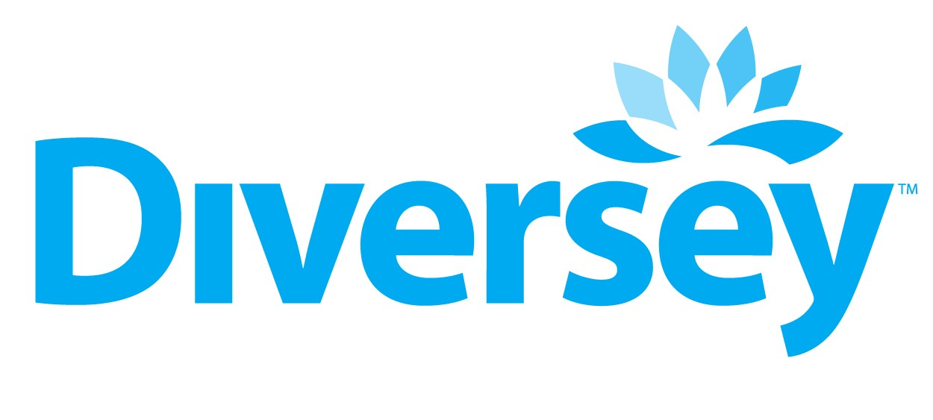
8310 16th St.
MS726
Sturtevant, WI 53177-1964
Point of Contact: Dena Johnson
Phone Number: 800-645-8888 or 262-631-2964
Fax Number: 800-599-9163 or 262-631-4038
Web Address: http://www.diversey.com
Business Size: Large
CUSTOMER INFORMATION:
- Table of awarded special item number(s) with appropriate cross-reference to item descriptions and
awarded price(s).
375-321 | Powdered and Liquid Machine Warewashing Compounds and Rinse Additives
375-323 | Laundry Cleaner, Powdered and Liquid and Dry Cleaning Chemicals
375-341 | Floor and Carpet Chemical Products
375-361 | Biodegradable Cleaner/Degreaser Non-phenolic and Non-petroleum
375-363 | Cleaner - Degreasers (Water and/or Solvent Based Detergent)
375-364 | Cleaners/Degreasers and Polishers
375-371 | Chemicals Dispensing Equipment and Systems
375-372 | Cleaning Chemicals Used with Dispensing Systems
375-391 | Auto Cleaners/Polishers, Air Fresheners, and Windshield Care
476-13 | Disinfectants
507-4 | Toilet Bowl Cleaner, liquid powder, and/or gel products for treatment and deodorization
507-2 | Permanent/Disposable dispenser housing and refills for the control of general institutional airborne odors, smoke, and sanitizing surfaces
507-8 | Sanitizers for Food Handling Areas
507-9 | Insect Repellant
852-1 | Toiletries

- Identification of the lowest priced model number and lowest unit price for that model for each special item number awarded in the contract.
375-321 | Liqu-A-Klor
375-323 | Super Impede
375-341 | Johnson Carpet Gen Purpose Spotter
375-361 | Stride Citrus Neutral Cleaner
375-363 | Mop & Brush Moss Squeegee Handle
375-364 | Sure Trac
375-371 | 32 oz Trigger Sprayers
375-372 | Triad Germicidal Cleaner
375-391 | Glad
476-13 | Quest #256
507-4 | Crew Natural Bowl Cleaner
507-2 | Good Sense TRU Odor Counteractants
525-2 | Liquid DTCA
507-8 | Johnson 512 Sanitizer Accumix
507-9 | Deep Woods Off
852-1 | Deep Kleen Bib Dispenser

1c. Hourly Rates: N/A.
2. Maximum order per Special Item Number
375-32 1 | $150,000
375-323 | $150,000
375-341 | $150,000
375-361 | $150,000
375-363 | $150,000
375-364 | $150,000
375-371 | $150,000
375-372 | $150,000
375-391 | $150,000
476-13 | $125,000
507-4 | $125,000
507-2 | $125,000
507-8 | $125,000
507-9 | $125,000
852-1 | $300,000

- Minimum order: $100.00
- Geographic coverage (delivery area): 48 Contiguous States and Washington, D.C.
5. Point(s) of production:

Diversey, Inc.
8311 16th St. Bldg 65
Sturtevant, WI 53177

DUBOIS
3630 East Kemper Rd. Sharonville, OH 45241

Canberra Corporation
3610 Holland-Sylvania Road Toledo, OH 43615

Northern Labs
5800 West Drive
PO Box 850
Manitowoc, WI 54221-0850

Royal Chemical Company
8679 S. Freeway Drive
Macedonia, OH 44056

Unilever
800 Sylvan Ave
Englewood Cliffs, NJ 07632

Virox
2770 Coventry Road
Oakville, ON L6H 6R1

Kutol Products
7650 Camargo Road
Cincinnati, OH 45243

Unipak
2501 Plantside Drive
Louisville, KY 40299

BonaKemi
4275 Corporate Center Dr.
Monroe, NC 28110

- Discount from list prices or statement of net price.
Discount from Price List
375-32 1 | 33% | - 76%
375-323 | 30% | - 59%
375-341 | 51% | & 40%
375-361 | 51% | & 40%
375-363 | 51% | & 40%
375-364 | 51% | & 40%
375-371 | 51% | & 40%
375-372 | 30% | - 64% & | 40%
375-39 1 | 40%
476-13 | 51% | & 40%
507-4 | 51% | & 40%
507-2 | 51%
507-8 | 51%
852-1 | 51%
507-9 | 40%

- Quantity discounts.
Price List Name |  | Discount
H&H |  | None
S-76 |  | 54% off list or an additional 6.82% off after 51% basic discount is taken
Consumer Brands | 100-149 Cases | 52.7% off list or an additional 21.2% off the 0-99 case price
 | 150-249 Cases | 54.8% off list or an additional 4.3% off the 100-149 case price
 | 250-449 Cases | 55.7% off list or an additional 2.0% off the 150-249 case price
 | 450 Cases and up | 56.6% off list or an additional 2.0% off the 250-449 case price
 | Truckload | 57.4% off list or an additional 2% off the 450 case price
Butchers |  | None

8. Prompt payment terms: 2%, 30 days, net 31.
- Government purchase cards are accepted at or below the micro-purchase threshold.
- Government purchase cards are accepted up to the micro-purchase threshold. No discounts.
10. Foreign items: None.
1 1a. Time of delivery: 5-10 business days
11 b. Expedited Delivery: 3-7 days ARO.
1 1c. Overnight and 2-day delivery: Overnight/Second Day available at customer expense. Contact
contractor.
11d. Urgent Requirements: Urgent requirements delivery available at customer expense. Contact
contractor.
12. F.O.B. point(s):
Origin freight prepaid and allowed for FSC groups 68 and 79. FOB destination for FSC group 85.
- Ordering address:
Diversey, Inc. 8310 16th St. MS 726 Sturtevant, WI 53177
- Ordering procedures: For supplies and services, the ordering procedures, information on Blanket Purchase Agreements (BPA’s), and a sample BPA can be found at the GSA/FSS Schedule homepage (fss.gsa.gov/schedules).
- Payment address:
Diversey, Inc. 1760 Payshere Circle Chicago, IL 60674
- Warranty provision: Standard
- Export packing charges: N/A.
- Terms and conditions of Government purchase card acceptance : Not accepted above the micro purchase level.
- Terms and conditions of rental, maintenance, and repair: N/A.
- Terms and conditions of installation: N/A.
- Terms and conditions of repair parts: N/A.
20a. Terms and conditions for any other services: N/A.
- List of service and distribution point: North America.
- List of participating dealers: N/A.
- Preventive maintenance: N/A.
- Special attributes. Chemicals packaged for dispensing equipment reduces product waste up to 50%. Envirobox corrugated is recyclable.
- Section 508 compliance information is available on Electronic and Information Technology (EIT) supplies and service. N/A. The EIT standards can be found at: www.Section508.gov .
- Data Universal Number System (DUNS) number. 01-8240817
- Diversey, Inc. is registered in the Central Contractor Registration (CCR) database.

