
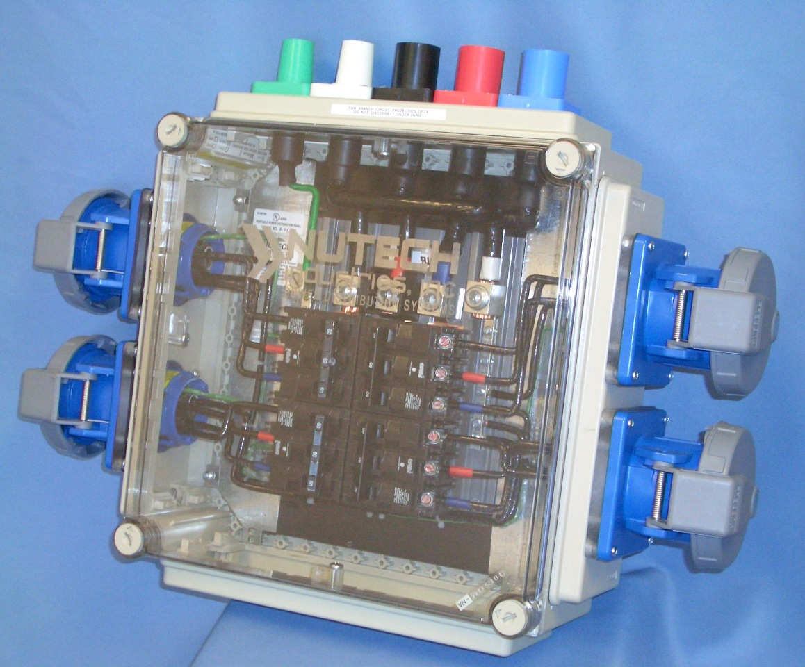
Post Office Box 97276
Las Vegas, Nevada 89120
Toll Free (800) 681-8954
Telephone (702) 597-0007
Fax (702) 597-1049

2 0 0 7 C A T A L O G

Nutech Industries, Inc.
5981 McLeod Drive
Las Vegas, NV 89120

GSA Contract #: GS-07F-0287T
Contract Period: March 16, 2007 to March 16, 2008
Minimum Order: $156.00
Duns: 794767673
Schedule Number: 056
Sin Numbers: 412 15

Table of Contents
About Us 1
Contact List 1
Satisfied Customers 2
Clear View Panels (CV) 3-6
CV-60-EXPO-1 3
CV-60-EXPO-2 3
CV-60-EXPO-3 3
CV-60-EXPO-4 3
CV-100-EXPO-1 4
CV-100-EXPO-2 4
CV-100-EXPO-3 4
CV-100-EXPO-4 4
CV-200-D 5
CV-200-EXPO-1 5
CV-200-EXPO-2 5
CV-200-EXPO-3 6
CV-200-EXPO-4 6
CV-200-EXPO-4 6
CV-30-EXPO-1 6
Metal Panel (MP) 7
MP-400-D 7
Booth Stringers (BS) 7
BS-1030 7
BS-1030-GFI 7
Dog Houses (DH) 8
DH-1000-F 8
DH-1000 8
DH-2000 8
Transformers 9
45KVA Transformer 9
75KVA Transformer 9
150 KVA Transformer 9
Custom Panel Request Form 10

About Us
Nutech Industries, Inc., is an electrical manufacturing firm which has developed new electrical products for portable temporary power distribution.
Our electrical distribution panels have been extensively tested and UL Listed by Underwriters Laboratories for use in motion picture, television studios, theater and stage, exhibition halls and similar facilities. These completed products meet or exceed the National Electrical Code (NEC) 2005, NFPA-70.
Labor costs for set-up and break-down is decreased significantly using our equipment and your savings will usually pay for the cost of this equipment within two or three shows.
We specialize in complete systems of distribution panels, lighting panels, splitter panels, booth stringers, doghouses, transformers, cord sets, adapters and specialty items.
The Clear View panels are made of high impact, non-corrosive, non-conductive polycarbonate enclosures which are smaller in size and lighter in weight than the older conventional metal panels. The clear covers and dead-fronts enable the user visual inspections without entering the panel. The polycarbonate cover will withstand impacts that would dent steel enclosures and possibly cause electrical faults to occur.
Booth stringers are used throughout the Expo industry for most trade shows, however, can be used in many other applications; e.g., stage and production, slot machines, concessions, meeting rooms, bands/orchestras and others. The older conventional stringer box has always been metal or rubber. Damage to one of these older boxes requires the removal of undamaged components in order to allow the damaged box to be repaired or replaced. Nutech uses a high impact polycarbonate box which, in case of damage, the removal of several screws will allow the user to repair or replace the damaged box without the removal of any other box or connector. Our stringers are competitively priced and will save thousands of dollars, in labor alone, over the lifetime of the product.
The doghouse distributes power 3-Phase in, 1-Phase out, 120V. Like the stringer box, it is made of high impact polycarbonate and has color coded 20 Amp, duplex receptacles to identify the circuits; i.e., black, red, and blue. Smaller in size and lighter in weight for portability and storage.
Transformers are custom built to meet your particular needs. Each transformer is made completely portable with a welded crash frame and welded lifting handle for large units and a two-wheel dolly to the smaller units. Any UL Listed single pole conductors can be added for quick connect and disconnect on the larger units and pin and sleeve connectors on the smaller ones.
Extension cords and panel adapters are all custom built to your particular specification using UL Listed components.
Contact List
Michael Smith, President msmith@nutechpower.com (702) 597-0007 ex.12
Robert Smith, Senior Vice President rsmith@nutechpower.com (702) 597-0007 ex.11
Samuel Suica, General Manager ssuica@nutechpower.com (702) 597-0007 ex.25
Mike Metcalfe, Productions Manager mmetcalfe@nutechpower.com (702) 597-0007 ex.15
Ashley Coe, Office Manager acoe@nutechpower.com (702) 597-0007 ex.10

Page 1

Satisfied Customers
NUTECH PRODUCTS ARE USED IN THE FOLLOWING FACILITIES
(partial listing)
Page 2

Anaheim Convention Center | Hilton Hotel - Del Mar | Pomona Fairplex
Atlanta Convention Center | Hilton Hotel - Las Vegas | Rhode Island Convention Center
Atlanta Summer Olympics '96 | Hilton Hotel - New York | Riviera Hotel/Casino - Las Vegas
Atlantic City Convention Center | Hilton Hotel - San Diego | Sahara Hotel/Casino - Las Vegas
Bally's Hotel/Casino - Las Vegas | Hilton Hotel - San Francisco | San Diego Convention Center
Bellevue Conference Center | Hyatt Regency Hotel - Burlingame | San Francisco Civic Center
Bellagio Hotel - Las Vegas | Hyatt Regency Hotel - Phoenix | San Jose Convention Center
Bushnell Memorial Hall | Hyatt Regency Hotel - San Diego | Sands Expo & Convention Center - Las Vegas
Caesar's Palace Hotel/Casino - Las Vegas | Kitsap Pavilion - Bremerton, WA | Santa Clara Convention Center
California Center for the Arts | Las Vegas Convention Center | Savanna Civic Center
Carson City Parks & Recreation | Long Beach Convention Center | Sheraton Grand Hotel - San Diego
Cashman Field Ball Park - Las Vegas | Lowe's Hotel - San Diego | Spokane Interstate Fair
Century Plaza - Los Angeles | Marriott Hotel - Anaheim | Stanford University
Charlotte Convention Center | Marriott Hotel - Denver Tech | Swan Hotel - Orlando
Cincinnati Convention Center | Marriott Hotel - Orlando | Town & Country - San Diego
City of Greeley, Colorado | Marriott Hotel - San Diego | Tropicana Hotel/Casino - Las Vegas
City of Humble, Texas | Marriott Hotel - San Francisco | University of Arizona - Theatrical Arts
City of Las Vegas, Nevada | Marta Rapid Transit - Atlanta | West Plains Civic Center
City of Long Beach, California | MGM Grand Garden | Westin Bonaventure Hotel - Los Angeles
City of Myrtle Beach, S.C | Mirage Hotel/Casino | Westin Resorts - Hilton Head Island
Classic Center - Athens | Monte Carlo Resort & Casino - Las Vegas | Boston Convention Center
Cococino County Fair - Flagstaff | Moscone Convention Center - San Francisco | City of Henderson, Nevada
Columbus Convention Center | Myrtle Beach Convention Center | City of La Crosse, California
Concourse - San Diego | Myrtle Beach Palace Theater | Hyatt Regency Hotel - Lake Tahoe
Del Coronado Hotel - San Diego | New Orleans Convention Center | Mesquite Rodeo
Del Mar Fairgrounds | New York Convention Center | Ocean City Convention Center
Denver Tech Marriott Hotel | New York State Fair | Ontario Convention Center, CA
Dolphin Hotel - Orlando | Oakland Civic Center | Rio Hotel - Las Vegas
Fairmont Convention Center | Oakland Convention Center | Paris Hotel - Las Vegas
Fresno Convention Center | Omni Hotel - Orlando | Ritz Carlton - Lake Las Vegas
Harbor Island Hotel - San Diego | Orlando Convention Center | Ritz Carlton - Coconut Grove, FL
Hawaii Convention Center - Honolulu | Palm Springs Convention Center | Schaumberg Convention Center
Hilton Hotel - Anaheim | Pasadena Convention Center | Wynn Hotel - Las Vegas
Hilton Hotel - Burlingame | Penn State University | MGM Grand Hollywood Theatre

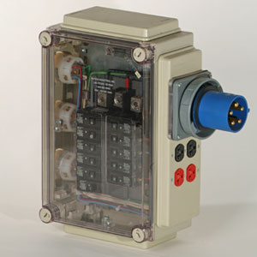
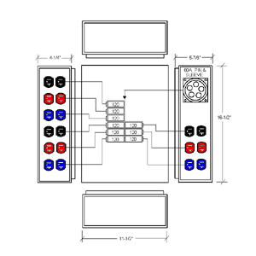
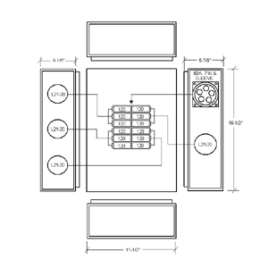
Clear View Panels
60 Amp Custom Built Clear View Panel that is UL Listed for Exposition Halls and Similar Locations; 3-Phase, 4-Pole, 5-Wire, 120/208Y. Enclosure is High Impact, Non-Conductive, Non-Corrosive Polycarbonate with Clear Lexan Dead-front. Incoming is 1 each Hubbell 60 Amp Pin & Sleeve Inlet (IEC309). Output is 3 each 20 Amp Hubbell or equal L21-20R Flanged Twist Lock Receptacles and 2 each 20 Amp Hubbell or equal 20 Amp Spec Grade Duplex Receptacles (Black).
CV-60-EXPO-1
60 Amp Custom Built Clear View Panel that is UL Listed for Exposition Halls and Similar Locations; 3-Phase, 4-Pole, 5-Wire, 120/208Y. Enclosure is High Impact, Non-Conductive, Non-Corrosive Polycarbonate with Clear Lexan Dead-front. Incoming is 1 each 60 Amp Hubbell Pin & Sleeve Inlet. Output is 9 each 20 Amp Hubbell or equal Spec Grade Duplex Receptacles (3 each Black, Red and Blue).
60 Amp Custom Built Clear View Panel that is UL Listed for Exposition Halls and Similar Locations; 3-Phase, 4-Pole, 5-Wire, 120/208Y. Enclosure is High Impact, Non-Conductive, Non-Corrosive Polycarbonate with Clear Lexan Dead-front. is 1 each Hubbell 60 Amp Pin & Sleeve Inlet (IEC309). Output is 3 each 20 Amp Hubbell or equal L21-20R Flanged Twist Lock Receptacles and 2 each 20 Amp Hubbell or equal 20 Amp Spec Grade Duplex Receptacles (Black).
100 Amp Custom Built Clear View Panel that is UL Listed for Exposition Halls and Similar Locations; 3-Phase, 4-Pole, 5-Wire, 120/208Y. Enclosure is High Impact, Non-Conductive, Non-Corrosive Polycarbonate with Clear Lexan Deadfront. Incoming is 1 each 100 Amp Pin & Sleeve Inlet (IEC309). Output is 15 each Hubbell or equal Specification Grade Duplex Receptacles (5 each Black, Red and Blue).
CV-60-EXPO-2
CV-60-EXPO-3
CV-60-EXPO-4
Page 3

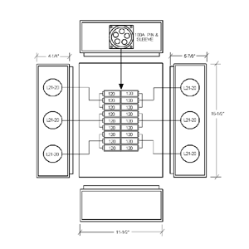
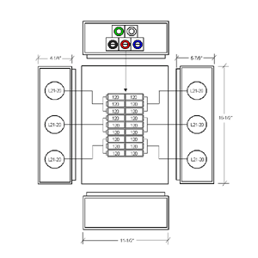
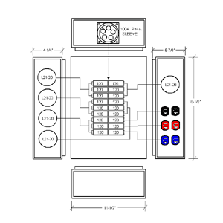
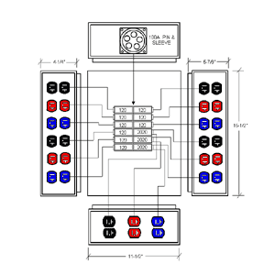
Clear View Panels
100 Amp Custom Built Clear View Panel that is UL Listed for Exposition Halls and Similar Locations; 3-Phase, 4-Pole, 5-Wire, 120/208Y. Enclosure is High Impact, Non-Conductive, Non-Corrosive Polycarbonate with Clear Lexan Deadfront. Incoming is 1 each 100 Amp Pin & Sleeve Inlet (IEC309). Output is 6 each 20 Amp Hubbell or equal L21-20R Flanged Twist Lock Receptacles.
CV-100-EXPO-1
100 Amp Custom Built Clear View Panel that is UL Listed for Exposition Halls and Similar Locations; 3-Phase, 4-Pole, 5-Wire, 120/208Y. Enclosure is High Impact, Non-Conductive, Non-Corrosive Polycarbonate with Clear Lexan Deadfront. Incoming is 5 each CamLok or equal (E1016 series panel mount; 1 each Black, Red, Blue [male], Green & White [female]. Output is 6 each 20 Amp Hubbell or equal L21-20R Flanged Twist Lock Receptacles.
100 Amp Custom Built Clear View Panel that is UL Listed for Exposition Halls and Similar Locations; 3-Phase, 4-Pole, 5-Wire, 120/208Y. Enclosure is High Impact, Non-Conductive, Non-Corrosive Polycarbonate with Clear Lexan Deadfront. Incoming is 1 each 100 Amp Pin & Sleeve Inlet (IEC309). Output is 5 each 20 Amp Hubbell or equal L21-20R Flanged Twist Lock Receptacles and 3 each Hubbell or equal Specification Grade Duplex Receptacles (1 each Black, Red and Blue).
100 Amp Custom Built Clear View Panel that is UL Listed for Exposition Halls and Similar Locations; 3-Phase, 4-Pole, 5-Wire, 120/208Y. Enclosure is High Impact, Non-Conductive, Non-Corrosive Polycarbonate with Clear Lexan Deadfront. Incoming is 1 each 100 Amp Pin & Sleeve Inlet (IEC309). Output is 15 each Hubbell or equal Specification Grade Duplex Receptacles (5 each Black, Red and Blue).
CV-100-EXPO-2
CV-100-EXPO-3
CV-100-EXPO-4
Page 4
Clear View Panels
100 Amp Custom Built Clear View Panel that is UL Listed for Exposition Halls and Similar Locations; 3-Phase, 4-Pole, 5-Wire, 120/208Y. Enclosure is High Impact, Non-Conductive, Non-Corrosive Polycarbonate with Clear Lexan Deadfront. Incoming is 1 each 100 Amp Pin & Sleeve Inlet (IEC309). Output is 6 each 20 Amp Hubbell or equal L21-20R Flanged Twist Lock Receptacles.
CV-100-EXPO-1
100 Amp Custom Built Clear View Panel that is UL Listed for Exposition Halls and Similar Locations; 3-Phase, 4-Pole, 5-Wire, 120/208Y. Enclosure is High Impact, Non-Conductive, Non-Corrosive Polycarbonate with Clear Lexan Deadfront. Incoming is 5 each CamLok or equal (E1016 series panel mount; 1 each Black, Red, Blue [male], Green & White [female]. Output is 6 each 20 Amp Hubbell or equal L21-20R Flanged Twist Lock Receptacles.
100 Amp Custom Built Clear View Panel that is UL Listed for Exposition Halls and Similar Locations; 3-Phase, 4-Pole, 5-Wire, 120/208Y. Enclosure is High Impact, Non-Conductive, Non-Corrosive Polycarbonate with Clear Lexan Deadfront. Incoming is 1 each 100 Amp Pin & Sleeve Inlet (IEC309). Output is 5 each 20 Amp Hubbell or equal L21-20R Flanged Twist Lock Receptacles and 3 each Hubbell or equal Specification Grade Duplex Receptacles (1 each Black, Red and Blue).
100 Amp Custom Built Clear View Panel that is UL Listed for Exposition Halls and Similar Locations; 3-Phase, 4-Pole, 5-Wire, 120/208Y. Enclosure is High Impact, Non-Conductive, Non-Corrosive Polycarbonate with Clear Lexan Deadfront. Incoming is 1 each 100 Amp Pin & Sleeve Inlet (IEC309). Output is 15 each Hubbell or equal Specification Grade Duplex Receptacles (5 each Black, Red and Blue).
CV-100-EXPO-2
CV-100-EXPO-3
CV-100-EXPO-4
Page 4

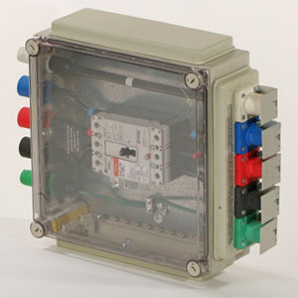
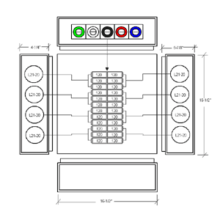
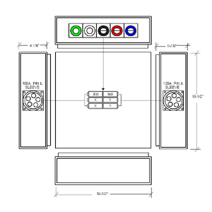
Clear View Panels
200 Amp Custom Built Clear View Panel that is UL Listed for Exposition Halls and Similar Locations; 3-Phase, 4-Pole, 5-Wire, 120/208Y. Enclosure is High Impact, Non-Conductive, Non-Corrosive Polycarbonate with Clear Lexan Deadfront. Incoming is 5 each E1016 Cam Type Device. 1 each Black, Red, Blue, Green & White. Output is 5 each E1016 Cam Type Device, 1 each Black, Red, Blue, Green & White.
CV-200-D
200 Amp Custom Built Clear View Panel that is UL Listed for Exposition Halls and Similar Locations; 3-Phase, 4-Pole, 5-Wire, 120/208Y. Enclosure is High Impact, Non-Conductive, Non-Corrosive Polycarbonate with Clear Lexan Deadfront. Incoming is 5 each 200Amp CamLok or equal (E1016 Series/Panel Mount; 1 each Black, Red, Blue [male], Green & White [female]). Output is 8 each 20 Amp Hubbell or equal L21-20R Flanged Twist Lock Receptacles.
200 Amp Custom Built Clear View Panel that is UL Listed for Exposition Halls and Similar Locations; 3-Phase, 4-Pole, 5-Wire, 120/208Y. Enclosure is High Impact, Non-Conductive, Non-Corrosive Polycarbonate with Clear Lexan Deadfront. Incoming is 5 each 200 Amp Cam Type Devices, 1 each Black, Red, Blue, Green & White. Output is 8 each 30 Amp Hubbell or Equal L21-30R Flanged Twist Lock Receptacles.
CV-200-EXPO-1
CV-200-EXPO-2
Page 5
200 Amp Custom Built Clear View Panel that is UL Listed for Exposition Halls and Similar Locations; 3-Phase, 4-Pole, 5-Wire, 120/208Y. Enclosure is High Impact, Non-Conductive, Non-Corrosive Polycarbonate with Clear Lexan Deadfront. Incoming is 5 each 200 Amp Cam Type Devices, 1 each Black, Red, Blue, Green & White. Output is 2 each 100 Amp Pin & Sleeve Outlets (IEC309).
CV-200-EXPO-3
Clear View Panels
200 Amp Custom Built Clear View Panel that is UL Listed for Exposition Halls and Similar Locations; 3-Phase, 4-Pole, 5-Wire, 120/208Y. Enclosure is High Impact, Non-Conductive, Non-Corrosive Polycarbonate with Clear Lexan Deadfront. Incoming is 5 each E1016 Cam Type Device. 1 each Black, Red, Blue, Green & White. Output is 5 each E1016 Cam Type Device, 1 each Black, Red, Blue, Green & White.
CV-200-D
200 Amp Custom Built Clear View Panel that is UL Listed for Exposition Halls and Similar Locations; 3-Phase, 4-Pole, 5-Wire, 120/208Y. Enclosure is High Impact, Non-Conductive, Non-Corrosive Polycarbonate with Clear Lexan Deadfront. Incoming is 5 each 200Amp CamLok or equal (E1016 Series/Panel Mount; 1 each Black, Red, Blue [male], Green & White [female]). Output is 8 each 20 Amp Hubbell or equal L21-20R Flanged Twist Lock Receptacles.
200 Amp Custom Built Clear View Panel that is UL Listed for Exposition Halls and Similar Locations; 3-Phase, 4-Pole, 5-Wire, 120/208Y. Enclosure is High Impact, Non-Conductive, Non-Corrosive Polycarbonate with Clear Lexan Deadfront. Incoming is 5 each 200 Amp Cam Type Devices, 1 each Black, Red, Blue, Green & White. Output is 8 each 30 Amp Hubbell or Equal L21-30R Flanged Twist Lock Receptacles.
CV-200-EXPO-1
CV-200-EXPO-2
Page 5
200 Amp Custom Built Clear View Panel that is UL Listed for Exposition Halls and Similar Locations; 3-Phase, 4-Pole, 5-Wire, 120/208Y. Enclosure is High Impact, Non-Conductive, Non-Corrosive Polycarbonate with Clear Lexan Deadfront. Incoming is 5 each 200 Amp Cam Type Devices, 1 each Black, Red, Blue, Green & White. Output is 2 each 100 Amp Pin & Sleeve Outlets (IEC309).
CV-200-EXPO-3

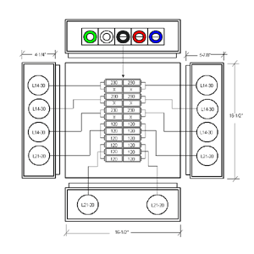
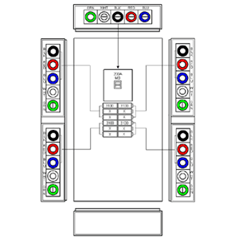
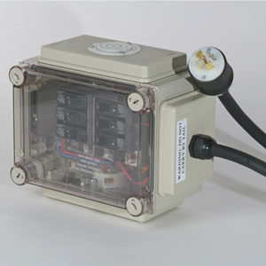
Clear View Panels
200 Amp Custom Built Clear View Panel that is UL Listed for Exposition Halls and Similar Locations; 3-Phase, 4-Pole, 5-Wire, 120/208Y. Enclosure is High Impact, Non-Conductive, Non-Corrosive Polycarbonate with Clear Lexan Deadfront. Incoming is 5 each 200Amp CamLok or equal (E1016 Series/Panel Mount; 1 each Black, Red, Blue [male], Green & White [female]). Output is 6 each 30 Amp Hubbell or equal L14-30R Flanged Twist Lock Receptacles and 4 each 20 Amp Hubbell or equal L21-20R Flanged Twist Lock Receptacles.
400 Amp Custom Built Clear View Panel that is UL Listed for Exposition Halls and Similar Locations; 3-Phase, 4-Pole, 5-Wire, 120/208Y. Enclosure is High Impact, Non-Conductive, Non-Corrosive Polycarbonate with Clear Lexan Deadfront. Incoming is 5 each E1016 Cam Type Device. 1 each Black, Red, Blue, Green & White. Output is 20 each E1016 Cam Type Device, 5 each Black, Red, Blue, Green & White.
30 Amp Custom Built Clear View Panel that is UL Listed for Exposition Halls and Similar Locations; 3-Phase, 4-Pole, 5-Wire, 120/208Y. Enclosure is High Impact, Non-Conductive, Non-Corrosive Polycarbonate with Clear Lexan Dead-front. Incoming is 1 each 30 Amp L21-30R Plug on 6’ of 10/5 SO Cable. Output is 2 each 20 Amp L21-20R Flanged Receptacles.
CV-200-EXPO-4
CV-400-EXPO-4
CV-30-EXPO-1
Page 6
Clear View Panels
200 Amp Custom Built Clear View Panel that is UL Listed for Exposition Halls and Similar Locations; 3-Phase, 4-Pole, 5-Wire, 120/208Y. Enclosure is High Impact, Non-Conductive, Non-Corrosive Polycarbonate with Clear Lexan Deadfront. Incoming is 5 each 200Amp CamLok or equal (E1016 Series/Panel Mount; 1 each Black, Red, Blue [male], Green & White [female]). Output is 6 each 30 Amp Hubbell or equal L14-30R Flanged Twist Lock Receptacles and 4 each 20 Amp Hubbell or equal L21-20R Flanged Twist Lock Receptacles.
400 Amp Custom Built Clear View Panel that is UL Listed for Exposition Halls and Similar Locations; 3-Phase, 4-Pole, 5-Wire, 120/208Y. Enclosure is High Impact, Non-Conductive, Non-Corrosive Polycarbonate with Clear Lexan Deadfront. Incoming is 5 each E1016 Cam Type Device. 1 each Black, Red, Blue, Green & White. Output is 20 each E1016 Cam Type Device, 5 each Black, Red, Blue, Green & White.
30 Amp Custom Built Clear View Panel that is UL Listed for Exposition Halls and Similar Locations; 3-Phase, 4-Pole, 5-Wire, 120/208Y. Enclosure is High Impact, Non-Conductive, Non-Corrosive Polycarbonate with Clear Lexan Dead-front. Incoming is 1 each 30 Amp L21-30R Plug on 6’ of 10/5 SO Cable. Output is 2 each 20 Amp L21-20R Flanged Receptacles.
CV-200-EXPO-4
CV-400-EXPO-4
CV-30-EXPO-1
Page 6

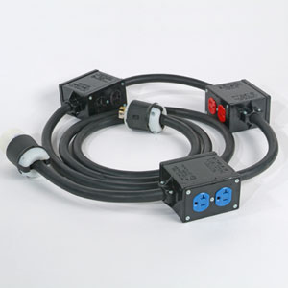
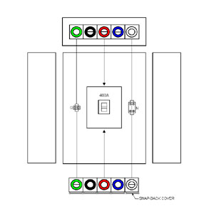
Metal Panel
Booth Stringers
200 Amp Custom Built Metal Panel with Clear Lexan Deadfront that is UL Listed for Exposition Halls and Similar Locations; 3-Phase, 4-Pole, 5-Wire, 120/208Y. Incoming is 5 each E1016 Cam Type Device. 1 each Black, Red, Blue, Green & White. Output is 5 each E1016 Cam Type Device, 1 each Black, Red, Blue, Green & White.
MP-400-D
Booth Stringer, UL Listed for Exposition Halls and Similar Locations, using 30' of 12 Gauge, 5 Conductor Cable on 10' Centers with 3 each High Impact, Non-Conductive, Non-Corrosive Polycarbonate Enclosures. Each Enclosure Housing 2 each Hubbell or equal 20 Amp, Spec Grade Duplex Receptacles #5352 (2 each - Black, Red and Blue). Incoming to be 1 each Hubbell or equal 20 Amp L21-20R Plug. Output to be 1 each Hubbell or equal 20 Amp, L21-20R Connector.
Booth Stringer, Ground Fault Protected, UL Listed for Exposition Halls and Similar Locations, using 30' of 12 Gauge, 5 Conductor Cable on 10' Centers with 3 each High Impact, Non-Conductive, Non-Corrosive Polycarbonate Enclosures. Each Enclosure Housing 1 each 20 Amp GFI Protected Duplex Receptacle with Test/Reset, and 1 each 20 Amp, Spec Grade Duplex Receptacles (1 each - Black, Red and Blue). Incoming to be 1 each Hubbell or equal 20 Amp Plug (Nema L21-20P). Output
to be 1 each 20 Amp, Connector (Nema L21-20R).
BS-1030
BS-1030-GFI
Page 7
Metal Panel
Booth Stringers
200 Amp Custom Built Metal Panel with Clear Lexan Deadfront that is UL Listed for Exposition Halls and Similar Locations; 3-Phase, 4-Pole, 5-Wire, 120/208Y. Incoming is 5 each E1016 Cam Type Device. 1 each Black, Red, Blue, Green & White. Output is 5 each E1016 Cam Type Device, 1 each Black, Red, Blue, Green & White.
MP-400-D
Booth Stringer, UL Listed for Exposition Halls and Similar Locations, using 30' of 12 Gauge, 5 Conductor Cable on 10' Centers with 3 each High Impact, Non-Conductive, Non-Corrosive Polycarbonate Enclosures. Each Enclosure Housing 2 each Hubbell or equal 20 Amp, Spec Grade Duplex Receptacles #5352 (2 each - Black, Red and Blue). Incoming to be 1 each Hubbell or equal 20 Amp L21-20R Plug. Output to be 1 each Hubbell or equal 20 Amp, L21-20R Connector.
Booth Stringer, Ground Fault Protected, UL Listed for Exposition Halls and Similar Locations, using 30' of 12 Gauge, 5 Conductor Cable on 10' Centers with 3 each High Impact, Non-Conductive, Non-Corrosive Polycarbonate Enclosures. Each Enclosure Housing 1 each 20 Amp GFI Protected Duplex Receptacle with Test/Reset, and 1 each 20 Amp, Spec Grade Duplex Receptacles (1 each - Black, Red and Blue). Incoming to be 1 each Hubbell or equal 20 Amp Plug (Nema L21-20P). Output
to be 1 each 20 Amp, Connector (Nema L21-20R).
BS-1030
BS-1030-GFI
Page 7

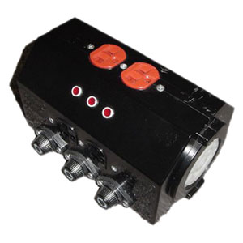
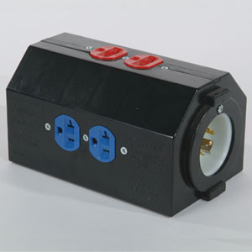
Dog Houses
Doghouse (Fused), UL Listed for Exposition Halls and Similar Locations. Enclosure is High Impact, Non-Conductive, Non-Corrosive Polycarbonate. The Enclosure Houses 3 each Hubbell or equal 20 Amp, Spec Grade Duplex Receptacles #5352 (1 each - Black, Red and Blue). Incoming to be 1 each Hubbell or equal 30 Amp L21-30P Inlet. Output to be 1 each Hubbell or equal 30 Amp, L21-30R Receptacle. The three 20 Amp duplexes are protected by three 20 Amp Fuses and has three neon phase indicator lights.
DH-1000-F
Doghouse (Thru), UL Listed for Exposition Halls and Similar Locations. Enclosure is High Impact, Non-Conductive, Non-Corrosive Polycarbonate. The Enclosure Houses 3 each Hubbell or equal 20 Amp, Spec Grade Duplex Receptacles #5352 (1 each - Black, Red and Blue). Incoming to be 1 each Hubbell or equal 20 Amp L21-20P Inlet. Output to be 1 each Hubbell or equal 20 Amp, L21-20R Receptacle.
Doghouse (Non Thru), UL Listed for Exposition Halls and Similar Locations. Enclosure is High Impact, Non-Conductive, Non-Corrosive Polycarbonate. The Enclosure Houses 3 each Hubbell or equal 20 Amp, Spec Grade Duplex Receptacles #5352 (1 each - Black, Red and Blue). Incoming to be 1 each Hubbell or equal 20 Amp Inlet (Nema L21-20P).
DH-1000
DH-2000
Page 8
Dog Houses
Doghouse (Fused), UL Listed for Exposition Halls and Similar Locations. Enclosure is High Impact, Non-Conductive, Non-Corrosive Polycarbonate. The Enclosure Houses 3 each Hubbell or equal 20 Amp, Spec Grade Duplex Receptacles #5352 (1 each - Black, Red and Blue). Incoming to be 1 each Hubbell or equal 30 Amp L21-30P Inlet. Output to be 1 each Hubbell or equal 30 Amp, L21-30R Receptacle. The three 20 Amp duplexes are protected by three 20 Amp Fuses and has three neon phase indicator lights.
DH-1000-F
Doghouse (Thru), UL Listed for Exposition Halls and Similar Locations. Enclosure is High Impact, Non-Conductive, Non-Corrosive Polycarbonate. The Enclosure Houses 3 each Hubbell or equal 20 Amp, Spec Grade Duplex Receptacles #5352 (1 each - Black, Red and Blue). Incoming to be 1 each Hubbell or equal 20 Amp L21-20P Inlet. Output to be 1 each Hubbell or equal 20 Amp, L21-20R Receptacle.
Doghouse (Non Thru), UL Listed for Exposition Halls and Similar Locations. Enclosure is High Impact, Non-Conductive, Non-Corrosive Polycarbonate. The Enclosure Houses 3 each Hubbell or equal 20 Amp, Spec Grade Duplex Receptacles #5352 (1 each - Black, Red and Blue). Incoming to be 1 each Hubbell or equal 20 Amp Inlet (Nema L21-20P).
DH-1000
DH-2000
Page 8

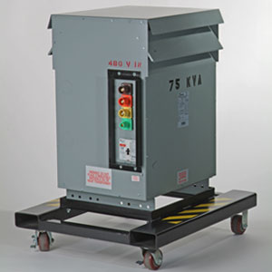
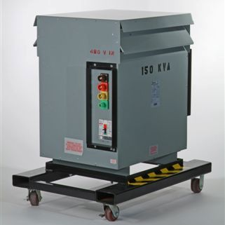
Transformers
480v Primary- 208/120y Secondary Incoming is 4 each E1016 Cam Type 480V Devices. Output is 5 each E1016 Cam Type Devices. Primary side protected by 60 Amp, 3Pole Circuit Breaker.
45KVA Transformer
480v Primary- 208/120y Secondary Incoming is 4 each E1016 Cam Type 480V Devices. Output is 5 each E1016 Cam Type Devices. Primary side protected by 100 Amp, 3Pole Circuit Breaker.
480v Primary- 208/120y Secondary Incoming is 4 each E1016 Cam Type 480V Devices. Output is 10 each E1016 Cam Type Devices. Primary side protected by 200 Amp, 3Pole Circuit Breaker.
75KVA Transformer
150KVA Transformer
Page 9
Pictures may not depict actual product
Transformers
480v Primary- 208/120y Secondary Incoming is 4 each E1016 Cam Type 480V Devices. Output is 5 each E1016 Cam Type Devices. Primary side protected by 60 Amp, 3Pole Circuit Breaker.
45KVA Transformer
480v Primary- 208/120y Secondary Incoming is 4 each E1016 Cam Type 480V Devices. Output is 5 each E1016 Cam Type Devices. Primary side protected by 100 Amp, 3Pole Circuit Breaker.
480v Primary- 208/120y Secondary Incoming is 4 each E1016 Cam Type 480V Devices. Output is 10 each E1016 Cam Type Devices. Primary side protected by 200 Amp, 3Pole Circuit Breaker.
75KVA Transformer
150KVA Transformer
Page 9
Pictures may not depict actual product

Custom Panel Request Form

Personal Information
Name:
Company:
Address:
City: State: Zip:
Phone: Fax:
E-mail:

Input Power
Phase: □ single phase □ 3 phase
Amperage per Phase:
Reverse Gender:
Input Connection:
Main Breaker Required?

Input Configuration: (i.e. Cam-Lok®, Pin & Sleeve, Twist Lock, other)

Outlet Types: (i.e. Edison, Cam-Lok®, Twist Lock, other)

Where do you plan to use this box?
□ Indoor
□ Indoor/Outdoor
□ Outdoor

Notes: (please note below any additional configurations or unique requirements)

Page 10
Custom Panel Request Form

Personal Information
Name:
Company:
Address:
City: State: Zip:
Phone: Fax:
E-mail:

Input Power
Phase: □ single phase □ 3 phase
Amperage per Phase:
Reverse Gender:
Input Connection:
Main Breaker Required?

Input Configuration: (i.e. Cam-Lok®, Pin & Sleeve, Twist Lock, other)

Outlet Types: (i.e. Edison, Cam-Lok®, Twist Lock, other)

Where do you plan to use this box?
□ Indoor
□ Indoor/Outdoor
□ Outdoor

Notes: (please note below any additional configurations or unique requirements)

Page 10

2007 Commercial Price List
Clear View Panels (CV)
CV-60-EXPO-1 $869.00
CV-60-EXPO-2 $798.00
CV-60-EXPO-3 $885.00
CV-60-EXPO-4 $838.00
CV-100-EXPO-1 $1,048.00
CV-100-EXPO-2 $983.00
CV-100-EXPO-3 $990.00
CV-100-EXPO-4 $929.00
CV-200-D $1,873.00
CV-200-EXPO-1 $1,355.00
CV-200-EXPO-2 $1,319.00
CV-200-EXPO-3 $1,417.00
CV-200-EXPO-4 $1,402.00
CV-400-EXPO-4 $3,533.00
CV-30-EXPO-1 $615.50
Metal Panel (MP)
MP-400-D $2,616.00
Booth Stringers (BS)
BS-1030 $223.00
BS-1030-GFI $326.00
Dog Houses (DH)
DH-1000-F $263.00
DH-1000 $158.00
DH-2000 $156.00
Transformers
45KVA Transformer $7,877.00
75KVA Transformer $9,678.00
150 KVA Transformer $10,210.00

2007 Commercial Price List
Clear View Panels (CV)
CV-60-EXPO-1 $869.00
CV-60-EXPO-2 $798.00
CV-60-EXPO-3 $885.00
CV-60-EXPO-4 $838.00
CV-100-EXPO-1 $1,048.00
CV-100-EXPO-2 $983.00
CV-100-EXPO-3 $990.00
CV-100-EXPO-4 $929.00
CV-200-D $1,873.00
CV-200-EXPO-1 $1,355.00
CV-200-EXPO-2 $1,319.00
CV-200-EXPO-3 $1,417.00
CV-200-EXPO-4 $1,402.00
CV-400-EXPO-4 $3,533.00
CV-30-EXPO-1 $615.50
Metal Panel (MP)
MP-400-D $2,616.00
Booth Stringers (BS)
BS-1030 $223.00
BS-1030-GFI $326.00
Dog Houses (DH)
DH-1000-F $263.00
DH-1000 $158.00
DH-2000 $156.00
Transformers
45KVA Transformer $7,877.00
75KVA Transformer $9,678.00
150 KVA Transformer $10,210.00

